Design Specification

2021

Contents

Overview 2

Design 2

Endpoints 2

# Overview

HigherLower game service exposes all basic end points to play game where a player can guess if the next number is higher or lower than the face value on the card opened on the table.

# Design

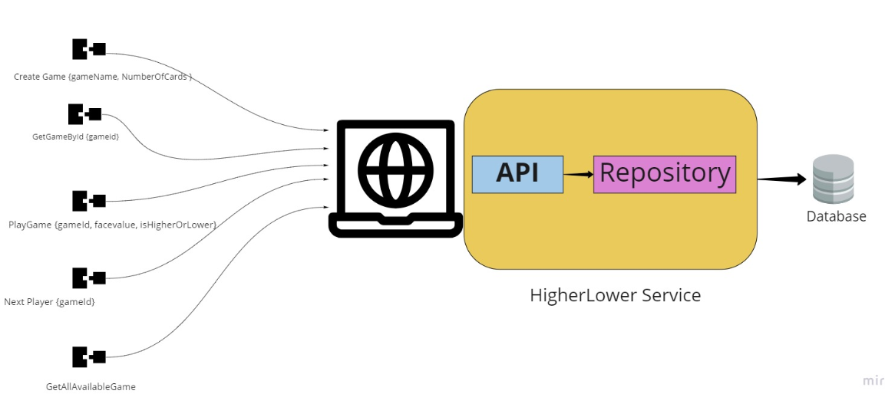

# Endpoints

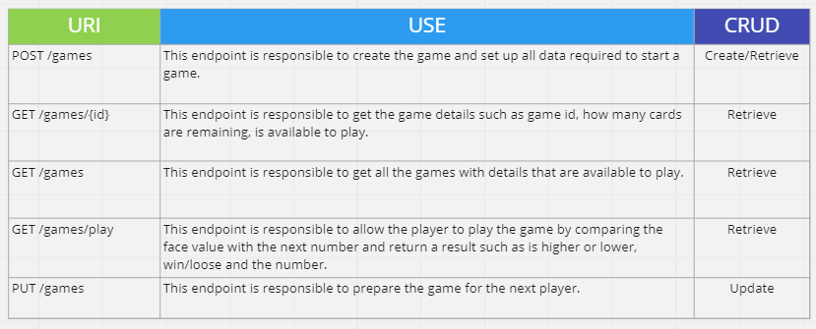

# Database

